Neshaminy MiniTHON Corporate Sponsor Packet | 2017
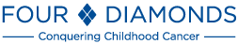
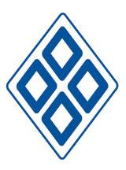
What is Neshaminy’s Mini-THON?

Neshaminy’s Mini -THON is an independent fundraising event benefitting the Four Diamonds Fund at Penn State Hershey Children’s Hospital and pediatric cancer research at Penn State College of Medicine. The Four Diamonds Fund is an organization devoted to fighting pediatric cancer. Neshaminy's Mini -THON consists of 6 consecutive hours during which students may not sit, squat, or kneel; they may only stand, dance, and participate in numerous competitions and activities organized for them throughout the day. All 6 hours are packed with music, food, sports, games, guest speakers, dancing, and grade-versus-grade competitions. The grade with the most points after events, such as dodgeball, carnival games, and a song lyrics competition wins. At the conclusion of the evening, the total amount of money raised is revealed, along with the winning grade of Mini -THON.

In 2015-2016, more than 100 middle and high schools, held Mini-THONs across the state of Pennsylvania and together raised a total of over 1.5 million dollars. Neshaminy High School was excited to join in the fight against pediatric cancer last year, raising over $15,000 and we are exciting to continue this tradition at our school!

While the NESHAMINY Mini -THON consists of grades competing against each other, our students understand the true purpose of this event. The motto of Mini-THON is "FTK", or "For The Kids", meaning that everything we do, from asking for donations and sponsorships to enjoying the event itself, is all to help kids with cancer. In addition to taking time throughout the 6-hour event to focus specifically on the cause, one part of our Mini-THON is dedicated to listening to the stories of families and kids who have been helped by the Four Diamonds and other cancer research facilities. The children’s presence at our Mini -THON helps dancers understand the importance of our event.

“One day, we will dance in celebration of beating cancer, but for now, we dance for the cure.”

Neshaminy School District
2001 Old Lincoln Highway • Langhorne, Pennsylvania 19047-3295

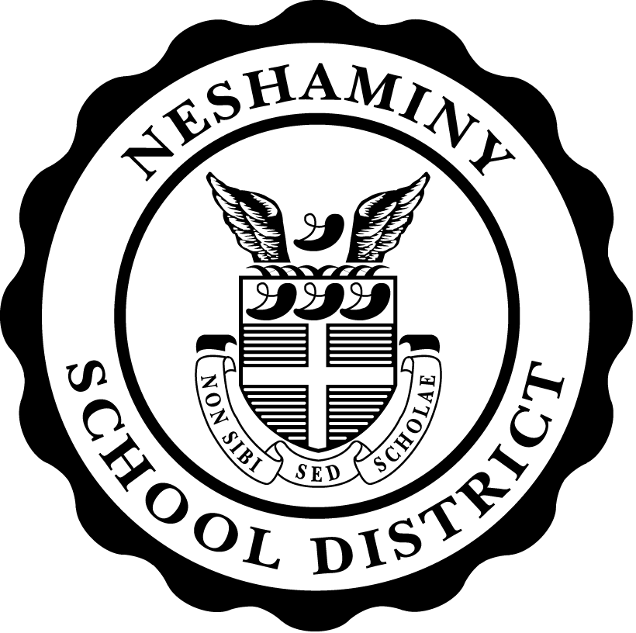
Joseph Jones III
Superintendent of Schools

Dear Sponsor,

We would like to invite you to become involved with Neshaminy High School’s 1st annual Dance Marathon (Mini-THON). Mini-THON is an event which raises money to aid families with children who are dealing with pediatric cancer. The event is on Saturday, May 6th, 2017. At this charitable event, students will be on their feet for six hours dancing and participating in a series of games and events. Mini-THON is centered on raising childhood cancer awareness. All proceeds go to the Four Diamonds Fund, an organization that works to assist families of childhood cancer and to initiate research for a cure.
The Four Diamonds Fund was founded in 1972 by Charles and Irma Millard in honor of their son, Christopher, who lost his battle with cancer at the age of 14. The Millards wanted to establish a program that would provide financial assistance for families whose children were being treated for cancer at Penn State’s Children’s Hospital. The proceeds from THON have helped lessen both the financial and emotional burdens of over 2,000 families struggling with the battle against pediatric cancer. Since its beginning, Penn State’s Dance Marathon (THON) has given over $100 million to fund groundbreaking cancer research.
Neshaminy High School is excited to join in the fight against pediatric cancer! Here is how you can get involved.

The donation categories are as follows:
$100+ | Silver Sponsor
$250+ | Gold Sponsor
$500+ | Platinum Sponsor
$1,000+ | Diamond Sponsor
$4,000+ | Four Diamond Sponsor

We thank you in advance for your commitment to this worthy cause. Please make checks payable to Neshminy High School and mark “Four Diamonds Fund” in the memo section. Email your company logo to kaubrey@neshaminy.k12.pa.us for use in publicity items that you qualify for. If you do not send us a logo, we will simply use your company name in all publicity tools we distribute.
Mail donations to Neshaminy High School (attn. Kim Aubrey), 2001 Old Lincoln Highway, Langhorne, PA 19047. If you have any questions, please email kaubrey@neshaminy.k12.pa.us. If you would like a receipt, you can donate online at www.neshaminyminithon.com . Any donation, large or small, allows Four Diamonds to give children a second chance at life. Please join the Neshaminy Mini-THON family.

Sincerely,

Kimberly Aubrey Elayna Curtin, Brooke Romberger, and Kelly Baradziej
Faculty Advisor Student Coordinators

Publicity Benefits | Silver | Gold | Platinum | Diamond | Four
 |  |  |  |  | Diamonds
 | $100+ | $250+ | $500+ | $1,000+ | $4,000+
Company name on Ad flyer | * | * | * | * | *
Company name listed on website | * | * | * | * | *
Company name on Ad banner at event | * | * | * | * | *
Company Logo (small) on Ad flyer |  | * | * | * | *
Company name, logo & link on website |  | * | * | * | *
Company Logo (large) on Ad flyer |  |  | * | * | *
Social media recognition |  |  |  | * | *
Brochure table at event |  |  |  | * | *
Company logo / link on front page of website |  |  |  | * | *
Company name / logo on event t-shirts |  |  |  | * | *
Company Logo (extra-large) on Ad flyer |  |  |  | * | *
Social media recognition and advertisements of products/specials |  |  |  | * | *
Company Banner at Event |  |  |  | * | *
Company “Shout Out” at NESHAMINY Mini-THON |  |  |  |  | *

Neshaminy Mini-THON Publicity Benefit Explanation
To benefit the Four Diamonds Fund
Company name/logo on Ad flyer | The Ad flyer goes out once in November just before NESHAMINY Mini-THON. Company name or logo size depends on level of contribution. It reaches hundreds of homes.
Company name/logo listed on  website | The company name/logo will be listed on the NESHAMINY Mini-THON website depending on contribution level. Location of name or logo also depends on the donation amount.
Company name on Ad banner at event | The company name will be written on the Ad banner displayed at NESHAMINY Mini-THON. All who attend will see this banner.
Company link on website | A link will be available on the NESHAMINY Mini-THON website directly to the homepage of the company website. Location of link on website depends on donation level (may include front page).
Company banner at event | The company can supply their own banner to be hung and displayed at NESHAMINY Mini-THON.
Brochure table at event | The company can supply brochures, vouchers, promotional material, etc., that will be displayed on a table at NESHAMINY Mini-THON.
Social media recognition | Company name and support will appear on NESHAMINY Mini-THON Facebook, Twitter, etc… (as will specials and products depending on level of donation)
Company name / logo on t-shirt | The company name and/or logo will be displayed on NESHAMINY Mini-THON t-shirts.
Company “Shout Out” at NESHAMINY Mini-THON | At the end of the event your company will be given individual recognition for your part in our total amount of money raised
May 6th, 2017

